SRUJANA KONDAMADUGULA

STUDENT ID: 16157492

EMAIL: skkd2@mail.umkc.edu

ADVANCED SOFTWARE ENGINEERING

LAB-3

1. HTML5 local storage.

In this Lab, I have extended Lab2 to implement HTML5 Local storage. The screen shot is as follows

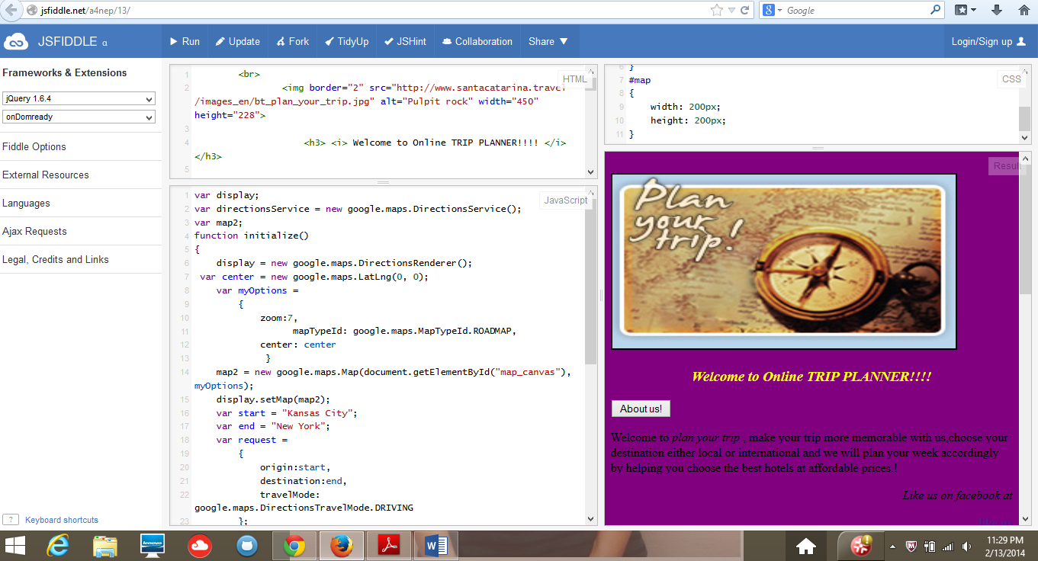

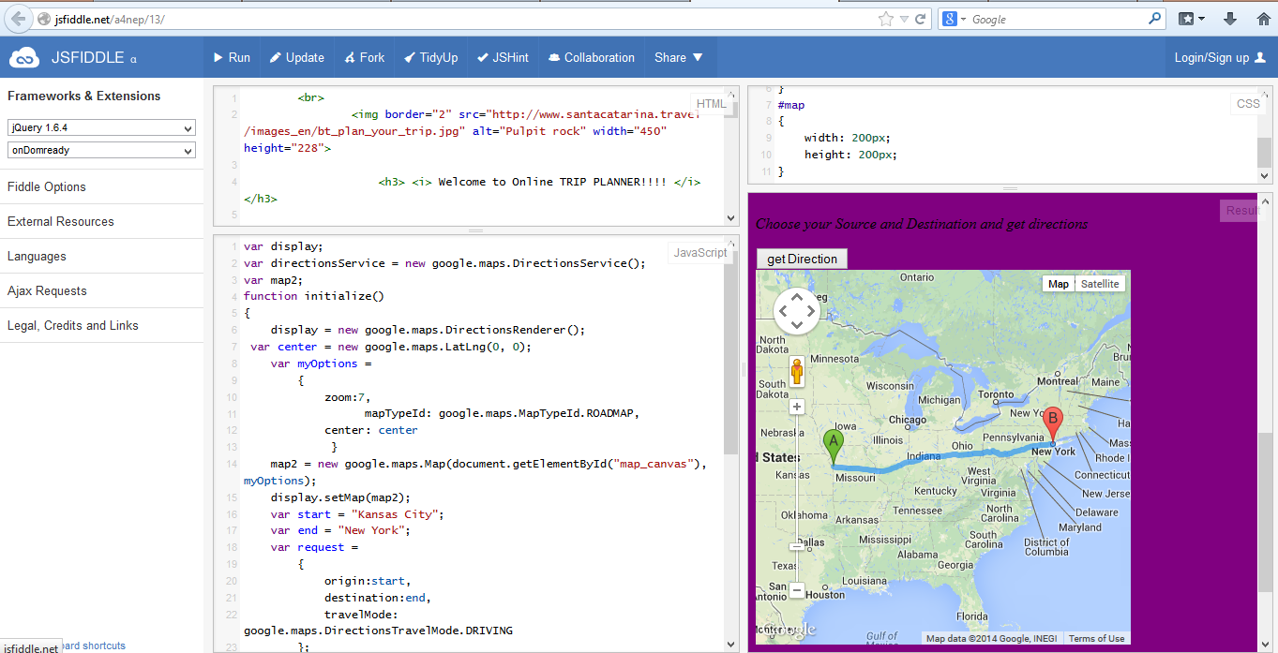

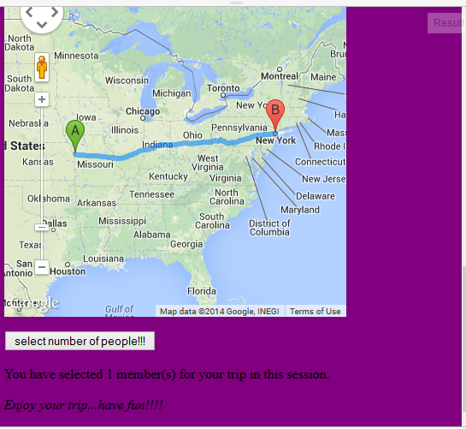

In this lab I mainly focused on local data storage, I added a button “select number of people”, when we click this button, a message appears saying “ you have selected n members for your trip in this session”. As we keep clicking this button, the number of members keep on increasing.

This is one of the applications of local data storage. When the window is closed, the number of members is reset and it comes back to normal.

When we keep clicking the button, the number of members are automatically increased, the screen shots for that are as follows.

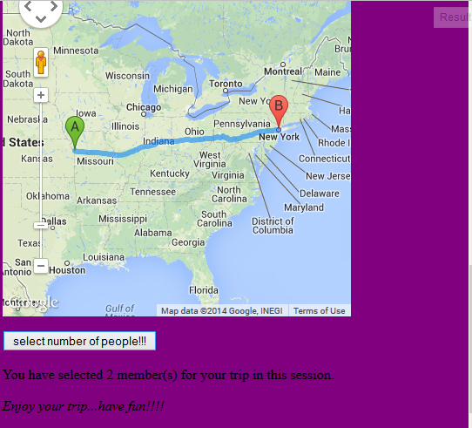

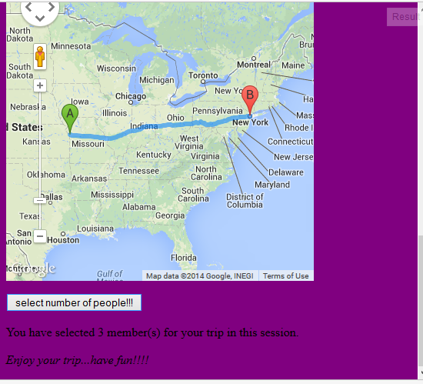

The JS fiddle link is <http://jsfiddle.net/a4nep/14/>

2. Mashup Application.

The screen shot of Mashup Application is as follows

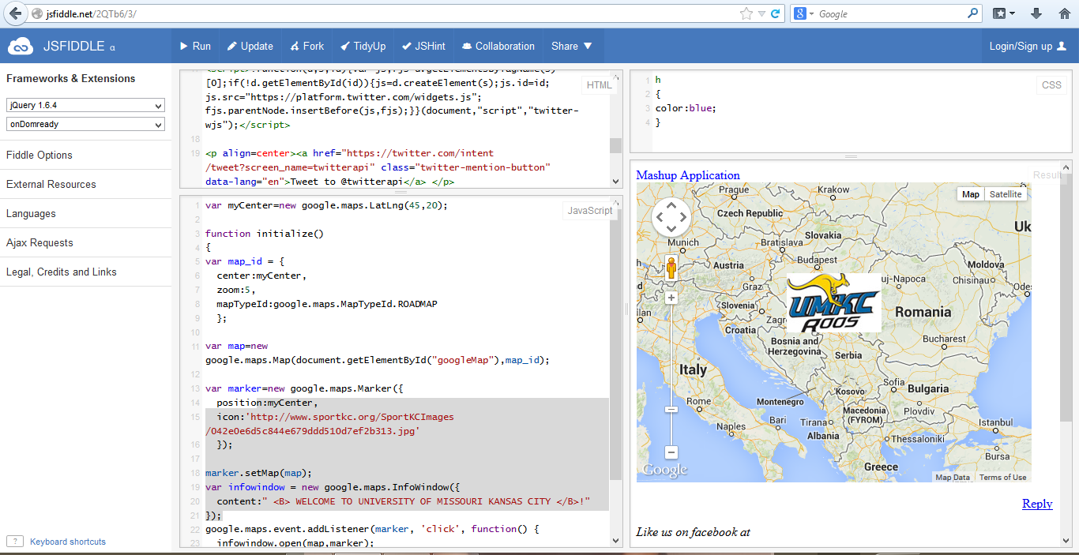

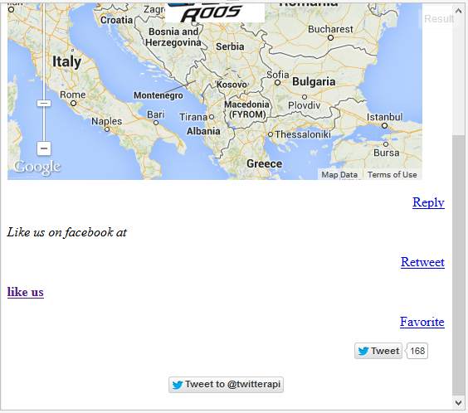

I have created a Mashup application which uses google maps, twitter api and I have inserted an image as a marker on the google maps and whenever the image is clicked, a message is displayed in the info window.

I also added a link of facebook page using the href attribute. Twitter api has been added.

The screen shots of result screen are as follows.

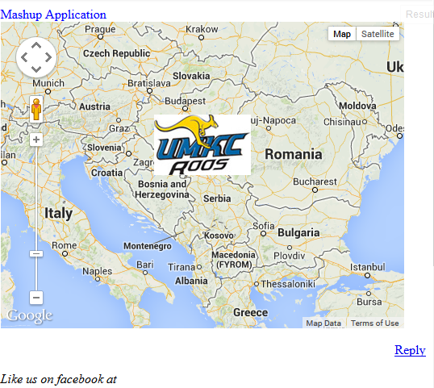

A click on the image above displays a message as shown.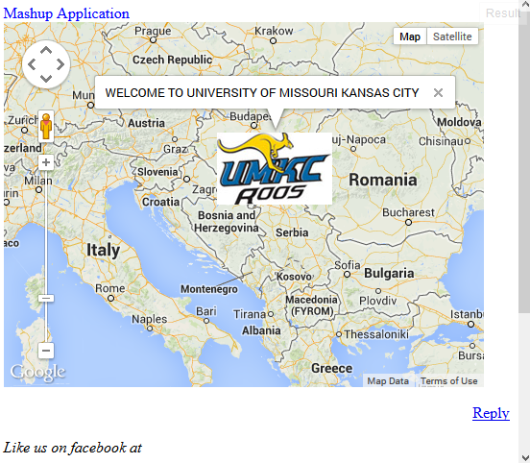

The jsfiddle link is <http://jsfiddle.net/2QTb6/4/>